**Overview of Clean Architecture**

Instead of "business logic" depend on "data access logic", this dependency is inverted; that means, the "data access logic" depend on "business logic".

**Benefit**: The business logic is highly clean-separated, independent of data storage and UI, unit-testable.

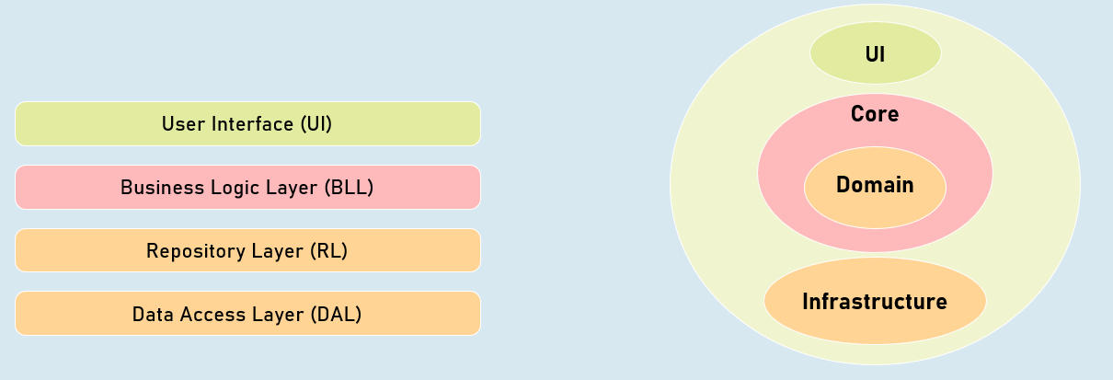

**Traditional Three-Tier / N-Tier Architecture**

1. User Interface (UI)
2. Business Logic Layer (BLL)
3. Repository Layer (RL)
4. Data Access Layer (DAL)

**Clean Architecture**

**UI**

1. Controllers, Views, View Models
2. Filters, Middleware

**Core**

1. Business Logic Services
2. Business Logic Interfaces
3. Data Transfer Objects (DTO)

**Domain**

1. Repository Interfaces
2. Entity Classes

**Infrastructure**

1. DbContext, Repositories
2. External API Calls

**Clean Architecture**

**Changing external system**

Allows you to change external systems (external APIs / third party services) easily, without affecting the application core.

**Scalable**

You can easily scale-up or scale-out, without really affecting overall architecture of the application.

**Database independent**

The application core doesn't depend on specific databases; so you can change it any time, without affecting the application core.

**Testable**

The application core doesn't depend on any other external APIs or repositories; so that you can write unit tests against business logic services easily by mocking essential repositories.

Clean architecture is earlier named as "Hexagonal architecture", "Onion architecture", "Domain-Driven Design", "Vertical Slice Architecture". Over time, it is popular as "clean architecture".

**Clean Architecture**

